**Automated Email Notification Setup for Jenkins using Gmail SMTP**

This task involves configuring an automated email notification system in Jenkins using Gmail's SMTP server. The goal is to enable Jenkins to send email notifications (such as build success or failure alerts) to a designated email address.

To achieve this, the task includes:

1. Setting up SMTP email configuration in Jenkins.
2. Using Gmail as the SMTP server, leveraging the smtp.gmail.com service.
3. Authenticating with Gmail using a Gmail account's app password to overcome two-factor authentication and increase security.
4. Ensuring the necessary Jenkins plugins, such as the "Email Extension" plugin, are installed and properly configured.
5. Testing the setup by triggering Jenkins jobs and verifying that email notifications are successfully sent.

**MANAGE JENKINS>SYSTEM CONFIGURATION**

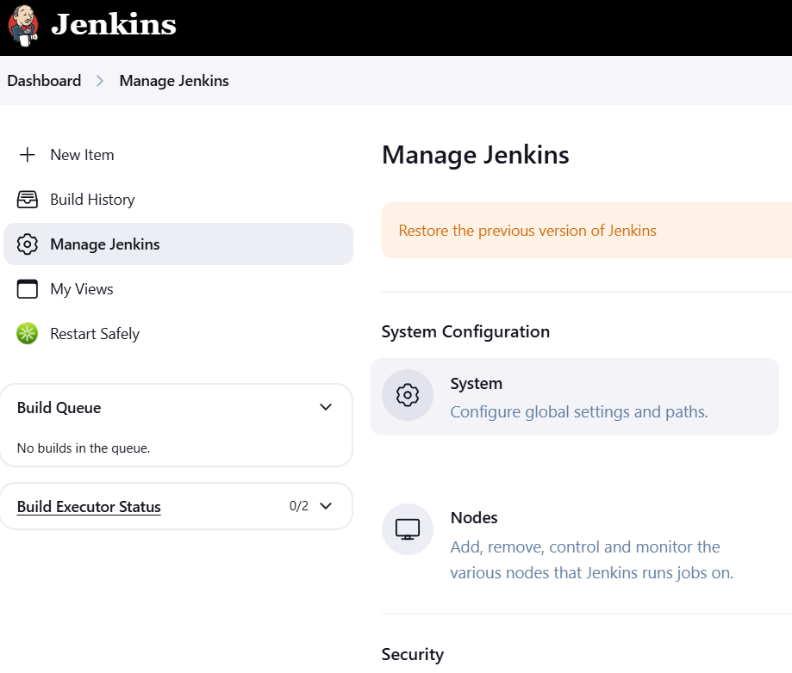

**E-MAIL NOTIFICATION**

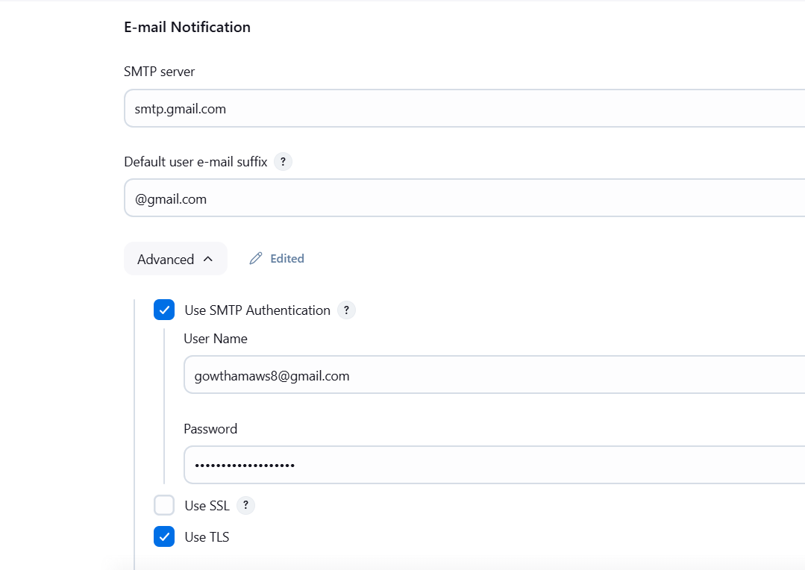

**ENABLE TLS, SMTP PORT=587**

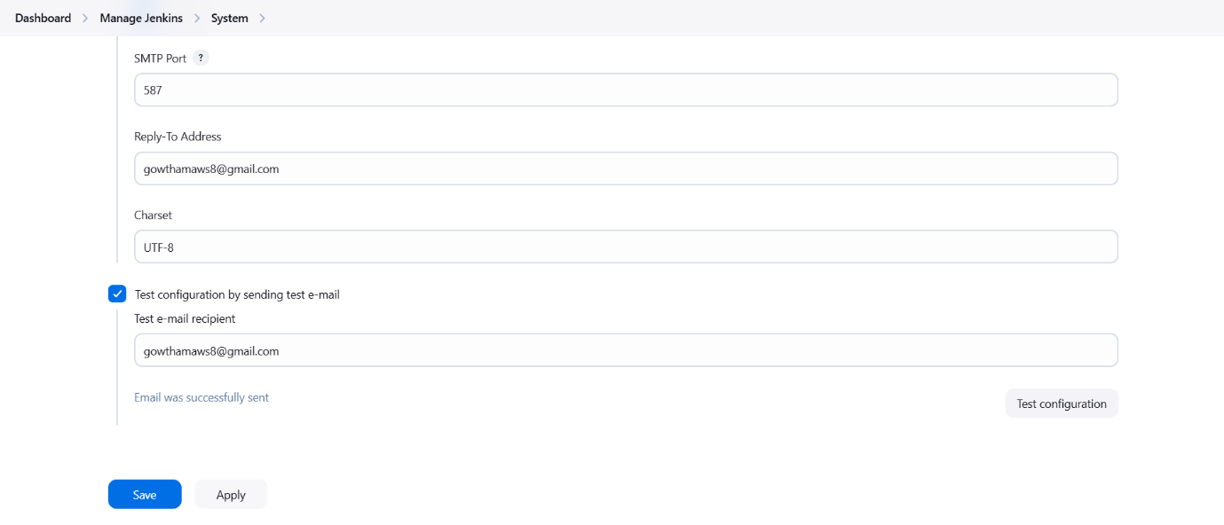

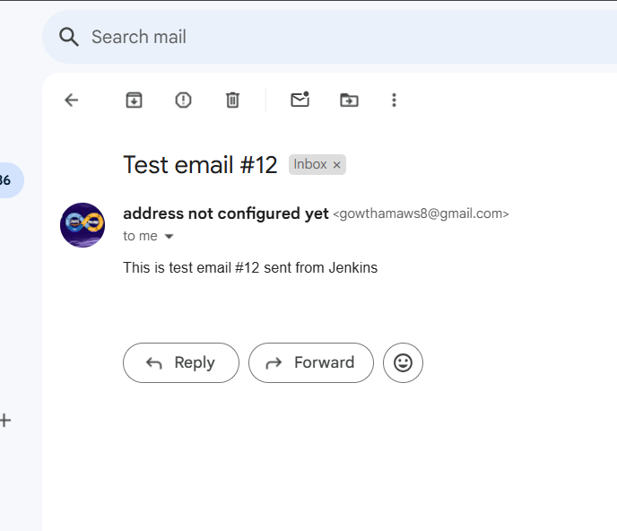

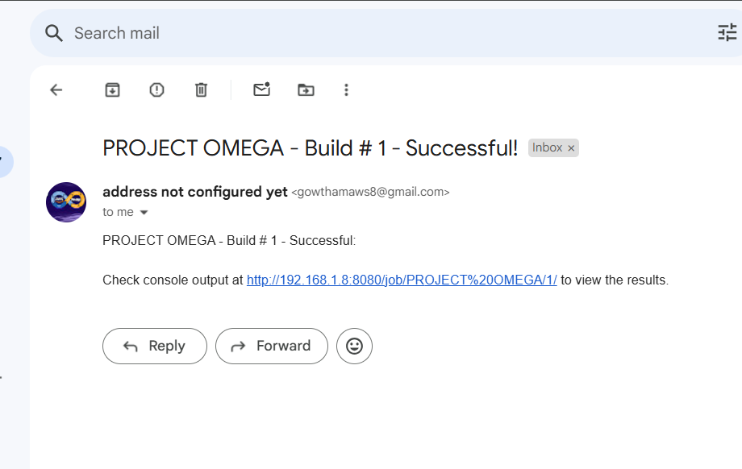

In conclusion, successfully configuring Gmail's SMTP server for email notifications in Jenkins enhances the communication and monitoring capabilities of the CI/CD pipeline. By using secure authentication methods like app passwords, the integration ensures reliable and timely alerts for build statuses, such as success or failure. This setup not only streamlines the notification process but also strengthens the security of the Jenkins environment, making it a vital part of automated workflows. As a result, the task contributes to improved efficiency and proactive issue resolution within the software development lifecycle.